Lab Practical #05:
Study the concept of VLAN using packet tracer.
Practical Assignment #05:
- Implement the different network structures in VLAN and VLAN trunking. Also check connectivity between them using ping command or PDU utility.
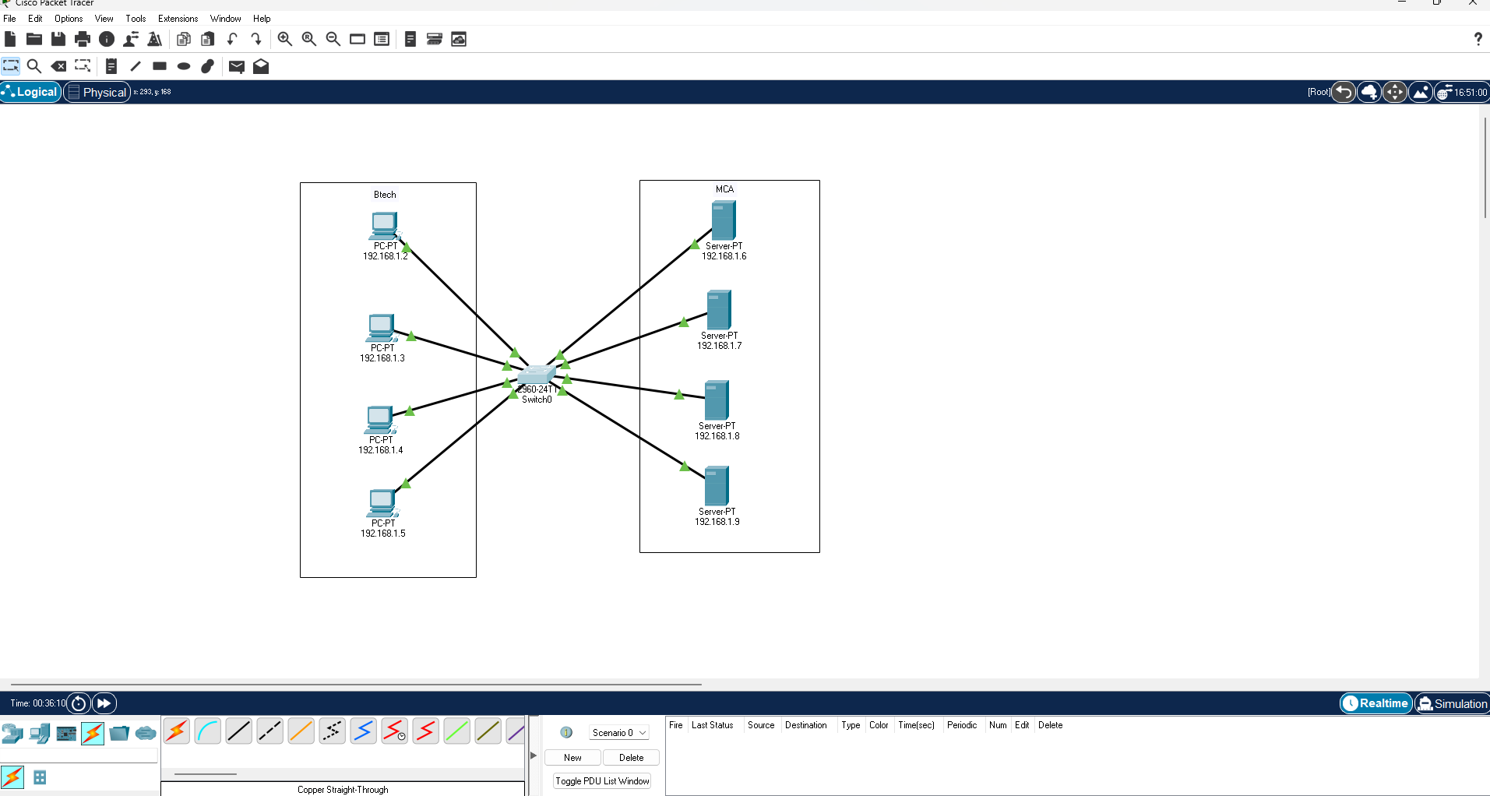

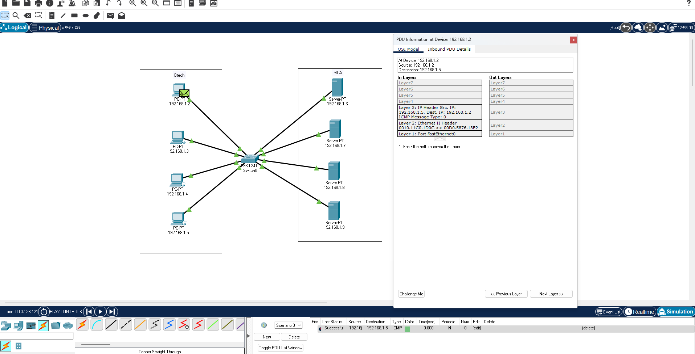
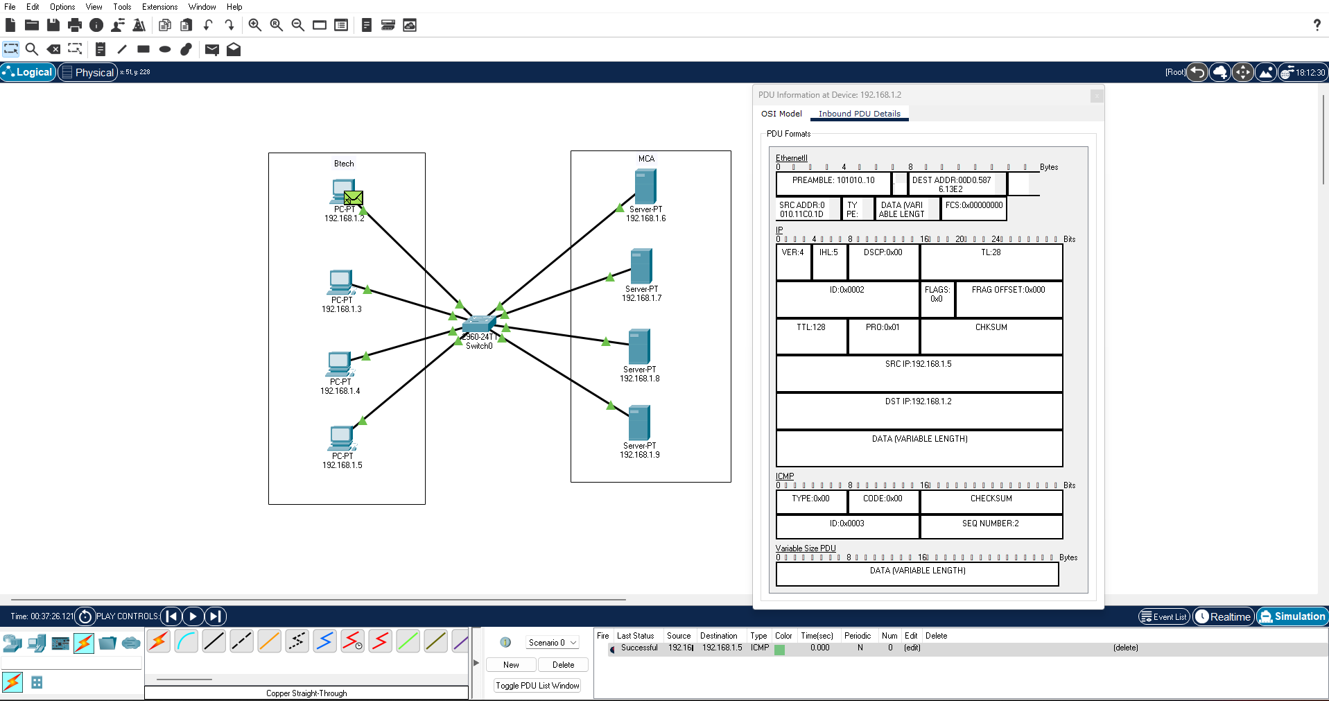

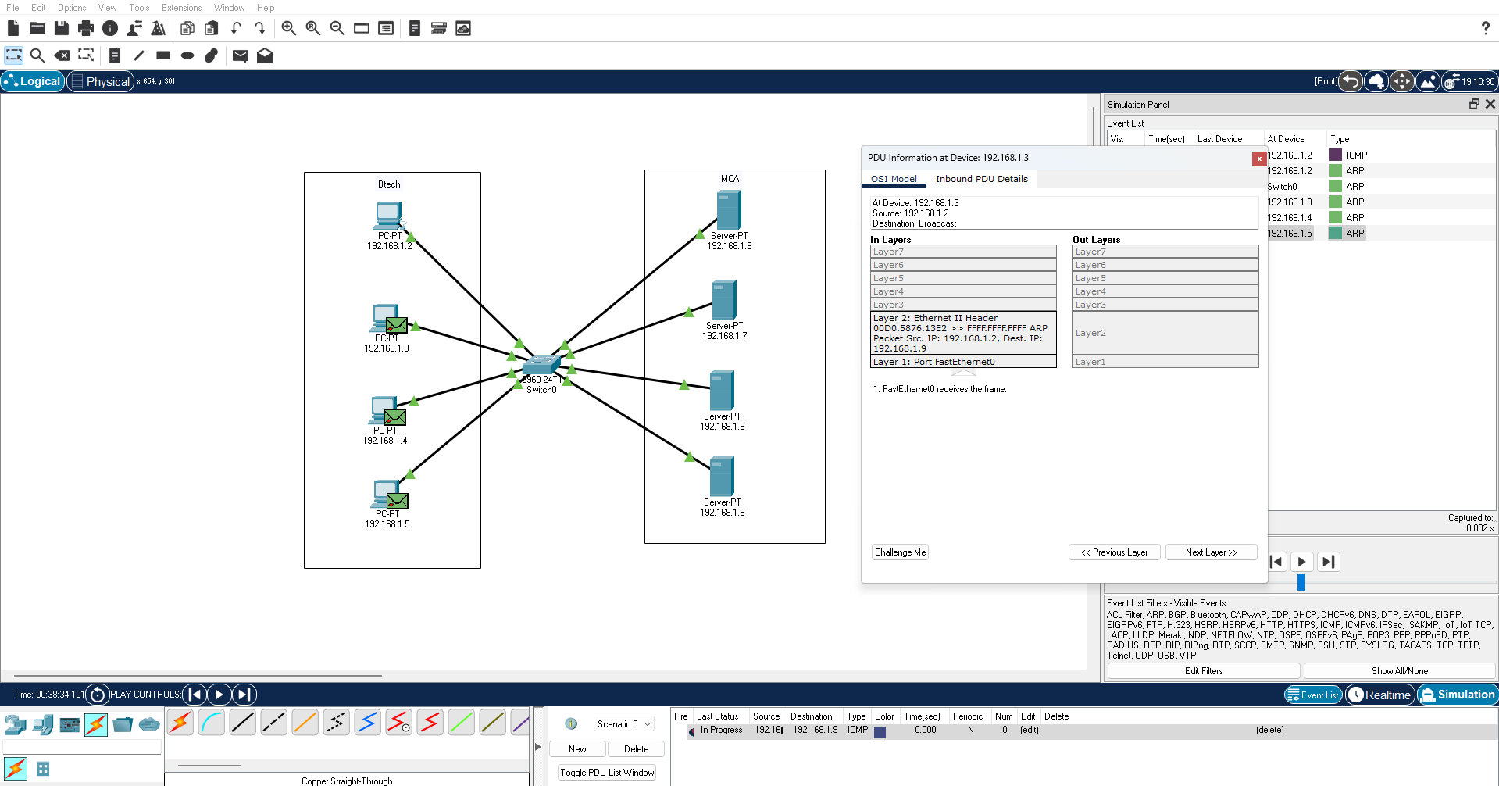

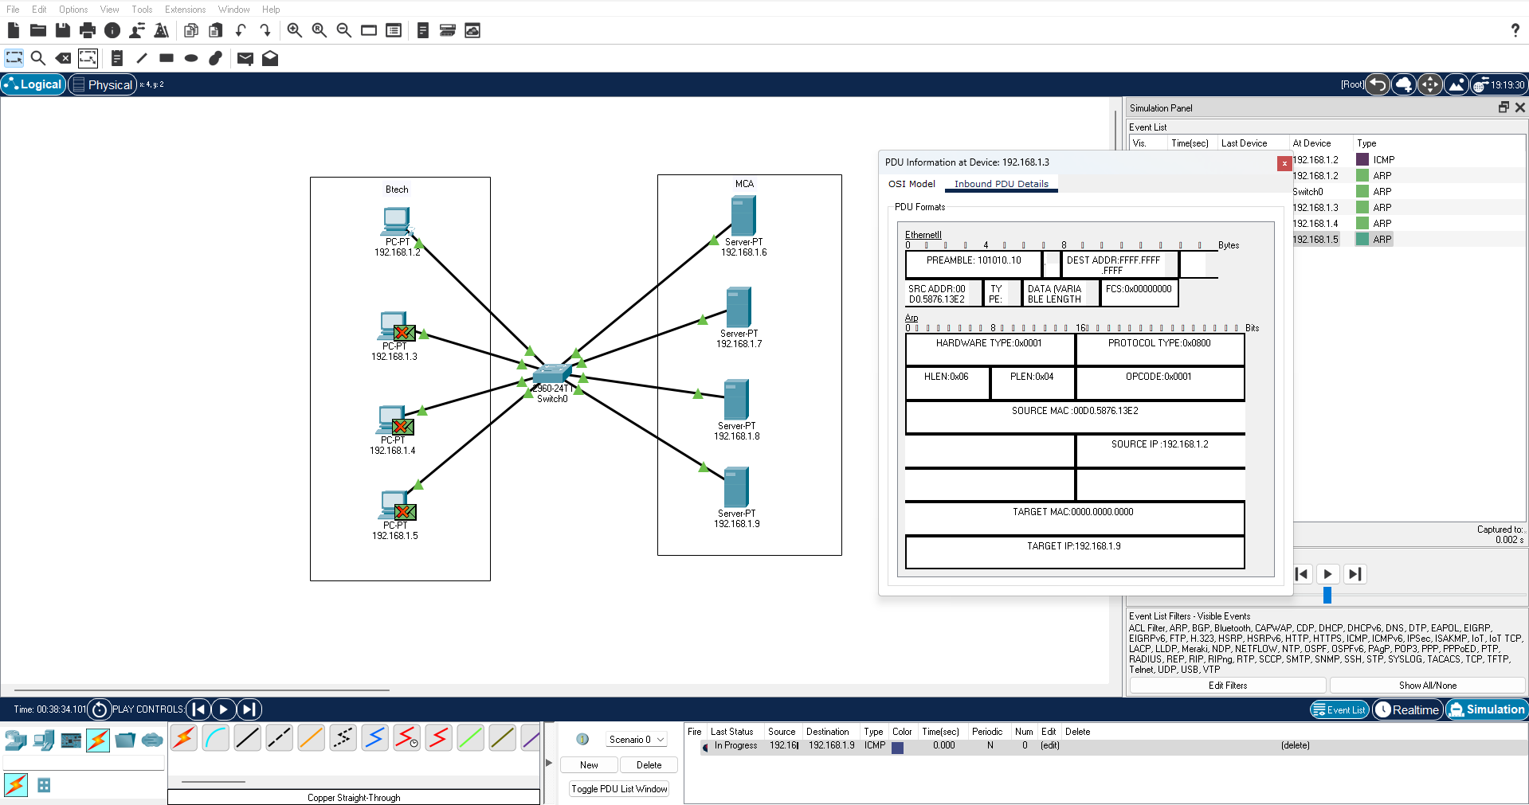

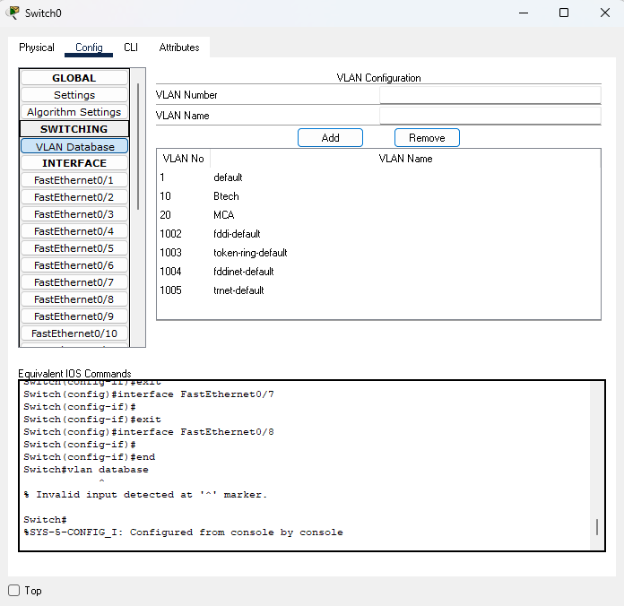

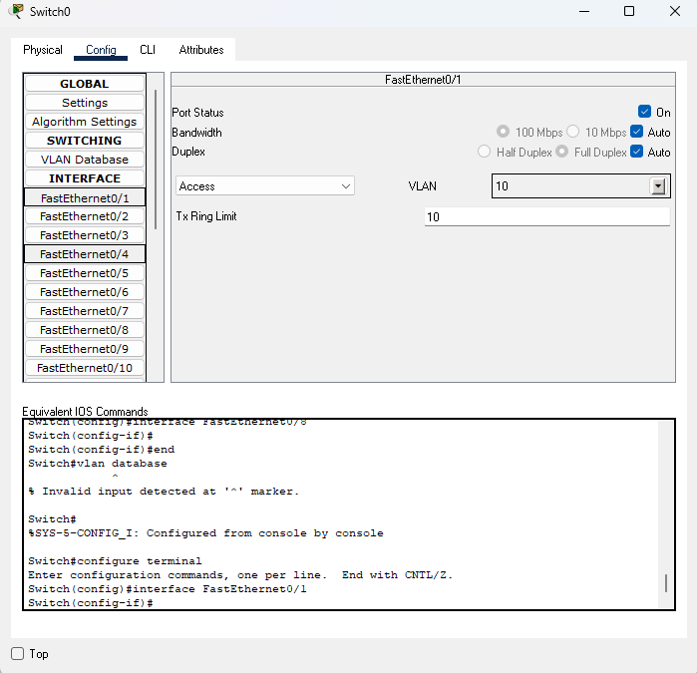

Steps to create VLANs in Packet Tracer:-

Step 1: Open Switch Configuration
- Double-click on the switch in Packet Tracer.
- Go to the Config tab.

Step 2: Create VLANs
- In the left panel, click on VLAN Database.
- In the VLAN section, add new VLANs by typing the VLAN ID and Name, then click Add.
  - Example:
    - VLAN ID: 10, Name: Sales
    - VLAN ID: 20, Name: HR

Step 3: Assign Ports to VLANs
- From the left panel, select each port (e.g., FastEthernet 0/1, 0/2, 0/3, 0/4).
- For each port:
  - Change Port Mode to Access.
  - Set VLAN Membership to the desired VLAN (e.g., VLAN 10 or VLAN 20).
- Example:
  - Ports Fa0/1 and Fa0/2 → VLAN 10 (Sales)
  - Ports Fa0/3 and Fa0/4 → VLAN 20 (HR)

Step 4: Verify VLANs
- Go back to VLAN Database.
- You should see the VLANs created (Sales and HR) and the ports assigned to them.

Step 5: Testing
- Connect PCs to the switch and assign IP addresses to them.
- PCs in the same VLAN will communicate with each other.
- PCs in different VLANs cannot communicate unless a router or Layer 3 switch is configured for Inter-VLAN Routing.

Instructions:
- Different VLANs configuration setup screenshot. (VLAN example given by lab faculty)
- Write steps to create VLANs in packet tracer.
- Mention IP address of each pc as label.
- Ping command or PDU screenshot between two VLANs.

